1. What is Boolean? Write down 3 different expression that results a Boolean type (i.e. 5 == 6)

The Boolean data type can be one of two values: **True** or **False**. We use Booleans in programming to make comparisons and to control the flow of the program.

6 % 5 == 0

6 >= 1

6 % 2 != 0

1. What is a flow chart? Draw flow chart for the following code snippet: (you can draw on a paper, take a picture of it)

if name == “Dinh Quy":

   print(“Hand some")

elif name == “Tuan Anh":

   even_more_handsome = True

else:

   webbrowser.open(“<https://www.youtube.com/watch?v=04854XqcfCY>”)

A flowchart is a type of diagram that includes steps, and conditions are arranged in a certain order to solve a problem

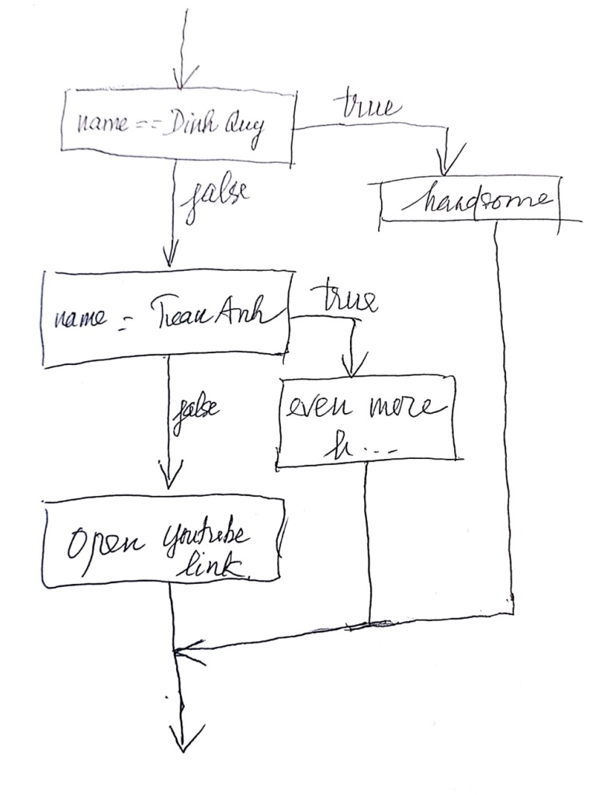

1. What is nested conditionals? Write a piece of code that uses nested conditionals

A “if...elif...else…” can be put inside another “if...elif...else…”. They are called nested conditionals.

Example:

num = int(input("Enter a number: "))

if num >= 0:

if num == 0:

print("Zero")

else:

print("Positive number")

else:

print("Negative number")